**Applications - Pop Quiz**

3. $N=a+2b^{2}$

Find *N* when  *=*  7 and  
 = -3

2. *A= 400 (1.12)n*

Find *A* when, *n* = 10

1. *V= u +at*

Find V, when *u =* 32,   
 *a=* -2 and *t =* 5

4. If you deposit $P in a bank account that earns interest at *k%* per annum, compounded annually, the amount in the account after *t* years will be *$A* where $A={P \left(1+ \frac{k}{100}\right)}^{t}$

Find the amount in the account after 5 years if $12,000 is deposited at 7% per annum compounded annually.

5 The spreadsheet below shows the various deposits and withdrawals from a bank account over a period of time. Column E, when complete, will show the balance after each transaction.

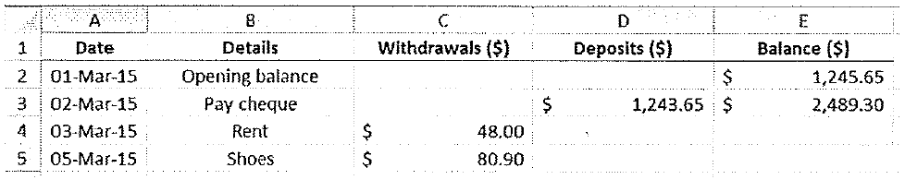

a) What formula was used to calculate the figure in cell E3?

b) What would the amount be in $ in cell E4?

c) What formula would be used in cell E4?